 **Group Final Project:**

**Insightful and Visually Appealing Dashboard**

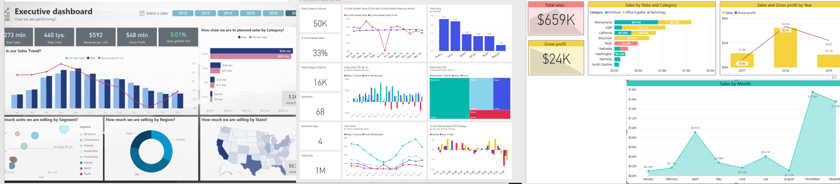

**Directions:**

Download and analyze the FoodMart data from Canvas. Explore the different files, look at their structure, peruse through the rows, and take note of the variables. Observe that some tables are fact data while others are lookup tables. Study how these matrices should be related to each other.

Your team's tasks are:

**Research Question**

**(1)** Come up with a research question that will drive your analysis of the data and ultimately determines what components are needed in your dashboard. Your inquiry should be answerable by the available information. For example, a research question might be: "Is there a relationship between a product’s price with its frequency of defects resulting in returns?"

**Design**

**(2)** Organize your thoughts and have a conversation with your group regarding how you answer your research question and sketch a layout of how your visualization display might look like. For example, what DAX method(s) (e.g., sum, average, mode, etc.) will you use to help arrive at a meaningful answer to your quest? Do you need a filter, hierarchy, DAX function, measure, calculated columns, additional miscellaneous table, and other modifiers? What kind of visual widgets (i.e., donuts, column charts, bars, map, matrix, card, area, et. al.) is most appropriate to present a compelling, insightful, and relevant visual objects that will help the user generate game-changing ideas and strengthen your conclusion (i.e., answer to your research question)? All team members have to arrive at a common understanding and agree upon the UI design and the approach to finding an answer to the research question. Elect a team recorder and start your documentation at this stage by capturing all the necessary details offered by all team members.

**Construct**

**(3)** Implement the plan that you designed in step #2. Use Power BI, Power Query, DAX, the data model to develop your solution taking advantage of the different exercises and modules learned in this class. The project should be constructed using these tools, and consider the use of eXtreme Programming techniques during this phase of development. Aside from the use of DAX function calls, there should be no programming needed for this project. The tools mentioned above should be used for reading the files, parsing, transforming, calculating (measures and calculated columns), and rendering graphical components. All members of the team should be involved in all parts of the final project.

**Verify**

**(4)** Inspect the accuracy of the numbers displayed in your visual widgets. Do they make sense? Compare the intelligence (the knowledge that can be inferred from your dashboard) against your research question and data source. Are the information skewed? Does it offer a new revelation or insight? Is it conducive at arriving at a new insight? Reexamine your process if you made a mistake along the way. Conduct a dialogue among yourselves and decide whether you should iterate through the procedure or go with your visualization.

**Conclusion**

**(5)** Arrive at a conclusion answering the research question. The plausible answer can swing to the affirmative or rejection of the research question. Provide a thorough explanation of the reasons behind the group's generalization. The response generated should be based on data and not on speculation. State the answers to the research question(s) you investigated. Your answers and the accompanying rationale should be approximately 200 words.

**Present**

**(6)** Complete your polished product in an appealing, intuitive, and impactful format. Compatible cloud-based presentation software may be used, including PowerPoint 360, Google Slides, Google Docs, or Prezi. The length of the demonstration should be between 10 to 15 minutes. Practice with your team how you will present your final project, and we will conduct the presentation at the tail-end of Week #10. All work is due before the start of Week #10's class. Your demonstration should thoroughly describe your methodology from research, observation, analysis, design, development, and verification.

**Individual Takeaways**

**(7)** The last three slides (or four depending on how many members are in the team) of your presentation should be the personal takeaways (one frame per person). Please share the top-three takeaways you gained from the Data Visualization course. These slides should be unique per student.

**Documentation & Submission**

**(8)** Submit only one copy of your project. Please put all the names of the team members on the cover of your deliverable. You may zip all the work and submit only one artifact in the discussion board. Again, designate only one person to tender your group's deliverable.  Individually, offer feedback to other groups’ project by pointing out what you like and how they can improve for future presentations.

**360 Degree Evaluation**

**(9)** Individually, please submit a 360-degree evaluation of your final project experience. Download the 360 eval from Canvas, fill-up the form, and then return them to me through Canvas.

|  |  |  |  |  |
| --- | --- | --- | --- | --- |
| GRADING RUBRIC (100 points) | | | | |
| Grading Criteria | 3  **Exceeds**  *Excellent*  Epic Wow | 2  **Meets**  *Satisfactory*  O.K. | 1  **Partially Meets**  *Below Expectations*  Not Yet | 0  **Does Not Meet**  *Unacceptable*  Fail |
| **Research Question –**The research question is profound, relevant, and adds value to the FoodMart business. | Research Question is excellent: 10 | Research Question is satisfactory: 8 | Research Question is confusing, or hard to follow: 6 | Unfortunately, no Research Question. |
| **Dashboard –** The appealing layout, interactive widgets used, and accuracy of data add value. | Dashboard layout is excellent and appealing: 30 | Dashboard layout is satisfactory : 24 | Dashboard layout is less appealing: 18 | Unfortunately, no dashboard. |
| **Documentation –** showed all the parts of the final project in a professional manner and proper grammar. Visualizations, computations, and output are included. | Documentation is excellent and explains the critical part of the project: 20 | Documentation is satisfactory: 16 | Documentation is hard to follow, or deficient: 12 | Unfortunately, no accompanying documentation. |
| **Presentation –** student presented the concept and all artifacts of the project in an understandable and engaging fashion. | Excellent presentation: 10 | Satisfactory presentation: 8 | Presentation has plenty of room for improvement: 6 | Unfortunately, no presentation. |
| **Conclusion –** takeaways andconclusion is profound and well defended backed up by empirical data. | Excellent conclusion and takeaways: 10 | Satisfactory conclusion and takeaways: 8 | Conclusion and takeaways are not impactful or meaningful: 6 | Unfortunately, there was no conclusion or no takeaways. |
| **Feedback –** student offered two or more feedback using the requirements. | Two or more feedback were excellent: 10 | Two or more feedback were satisfactory: 8 | Feedback are not impactful or meaningful: 6 | Unfortunately, no feedback provided to others. |
| **Time Management –** candidates used time wisely during development, presentation, and all aspects of the work submitted in a timely fashion. | Work submitted promptly: 10 | Submitted within the allotted time: 8 | Submitted late: 6 | Unfortunately, too long, too short, or untimely. |